**Ridge filters for image processing :**

1. **Import ridge filters :**

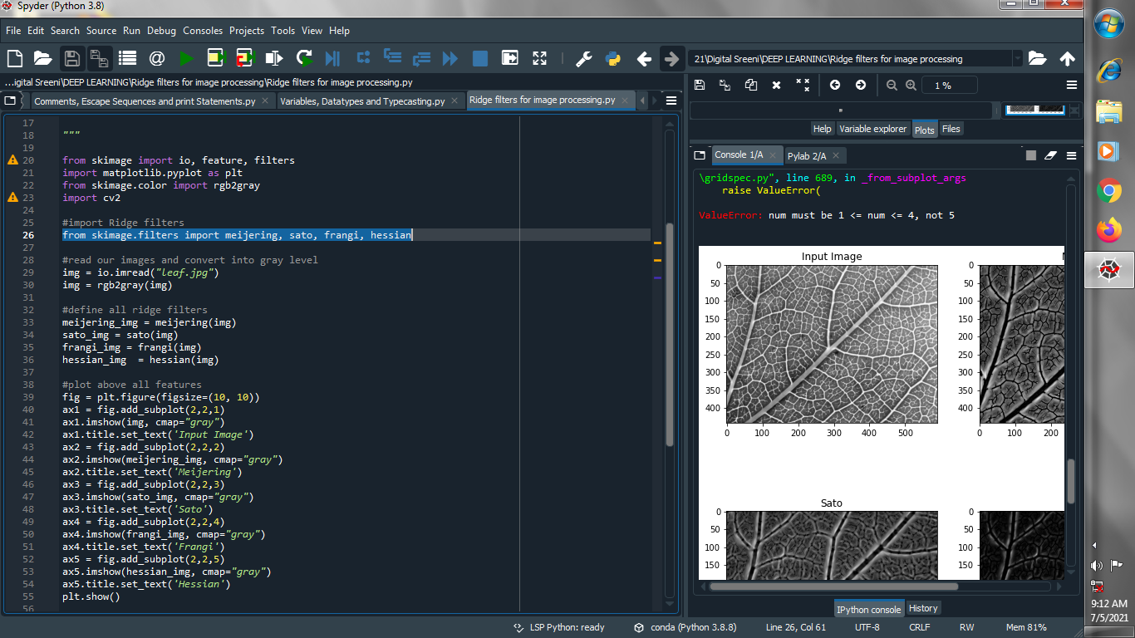

1. **Read our images and convert it into gray level image :**

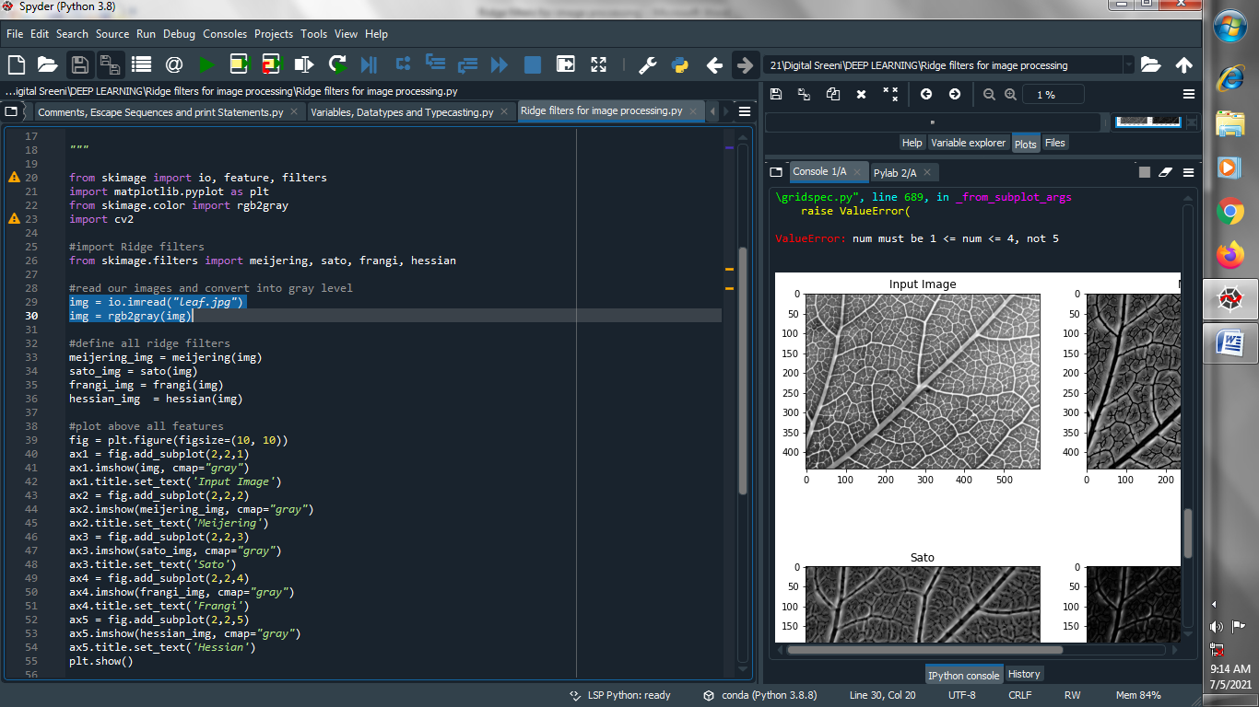

1. **Define all ridge filters :**

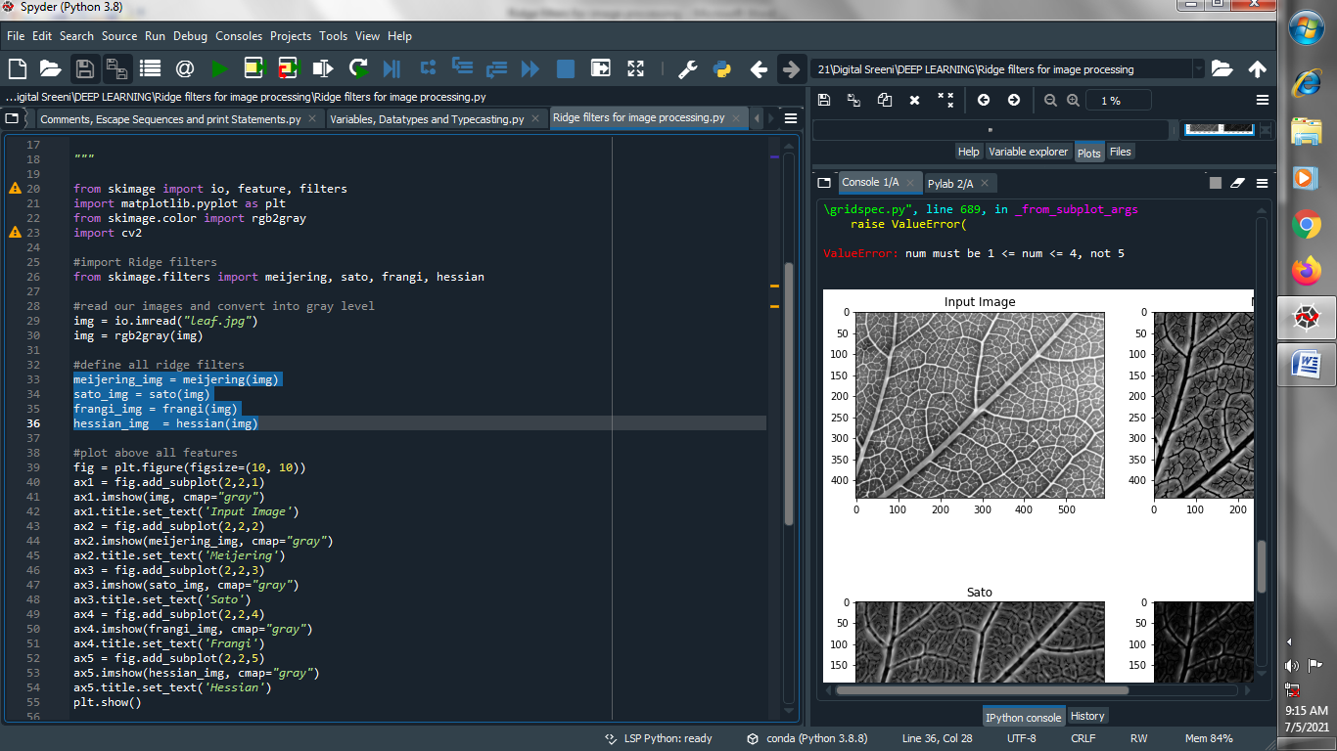

1. **Plot above all features :**

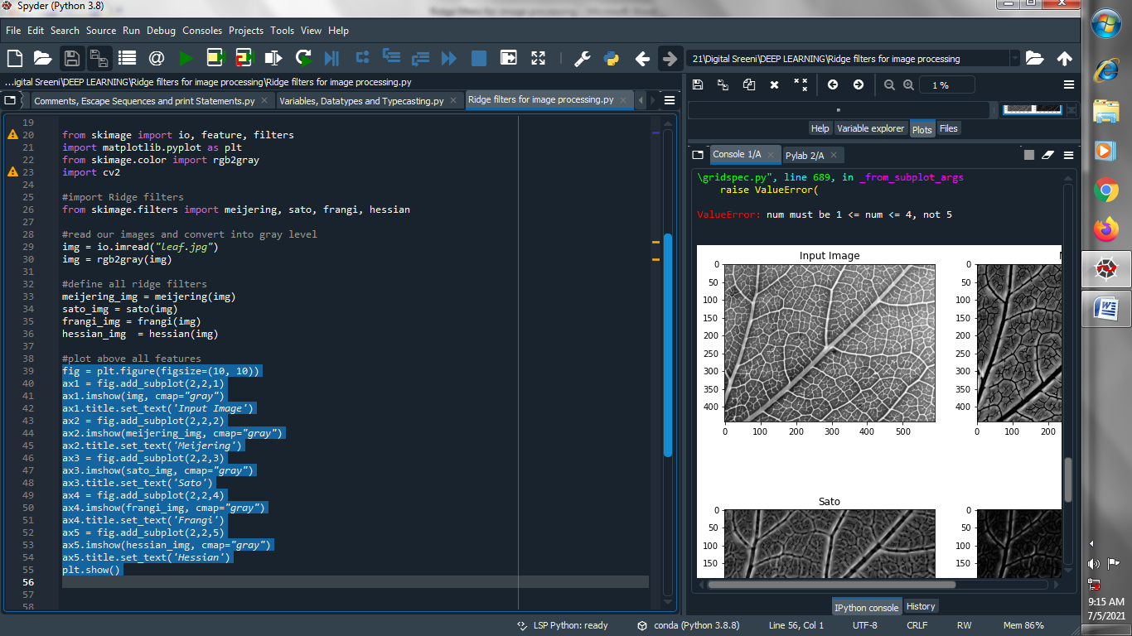

**Output :**

